Update for key stakeholders
11 November 2022

Vaccination
As at 2 November, vaccination figures across the whole of the NHS Highland area were:
 | Over 65s % complete | Health & social care staff % complete | 5-65s at risk % complete
COVID | 73.9 | 38.8 | 30.8
Flu | 68.4 | 38.8 | 27.7

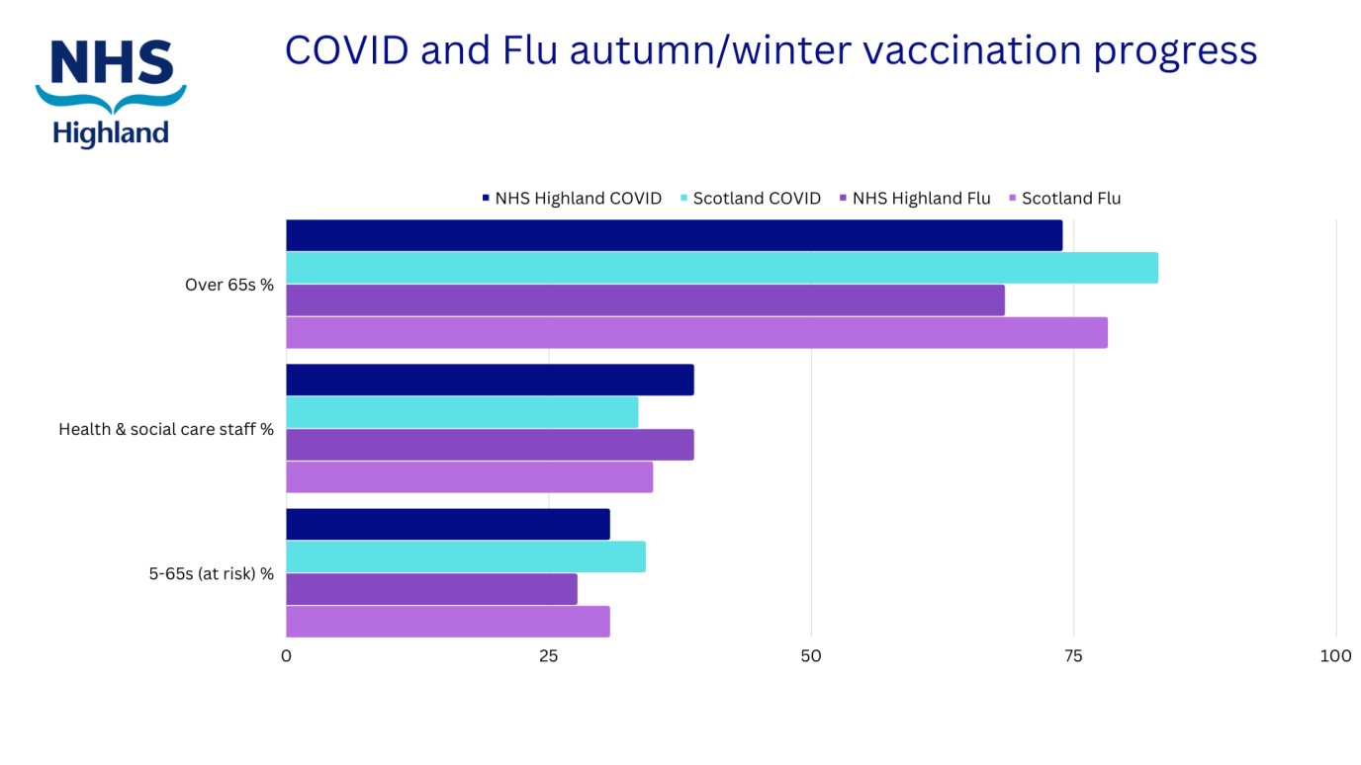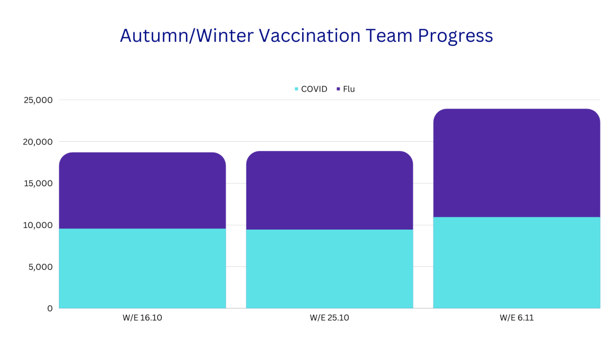

Strike action

We are planning for all eventualities resulting from strike action in order to keep essential services running. We will issue more information if/when strike dates are confirmed.

Feedback
If you have comments or queries please contact nhshighland.feedback@nhs.scot

